**Southwell Racecourse**

|  |  |
| --- | --- |
| **Position:** | Greenkeeper |
| **Contract type:** | Permanent |
| **Hours of work:** | 40 hours (5 days out of 7) |

* 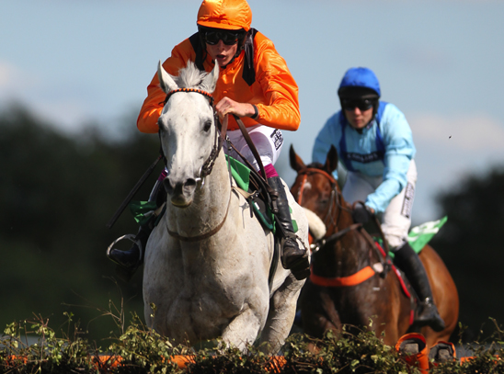
* 

**About the role**

Reporting to the Head Greenkeeper, the Greenkeeper will be responsible and accountable for maintenance and presentation of the entire Golf Course, the Club House surrounds and driving range, in line with the requirements of the Club Greens committee and the Executive.

**Key responsibilities for the role will include**

1. To cut and repair the greens and fairways as required,
2. To ensure that they are in the best possible condition and to the highest standards of presentation at all times
3. To carry out aspects of turf management expected from the position, the main ones of which are identified below:
   * Switching and brushing
   * Mowing banks, rough, semi rough, fairways, surrounds, tees, greens,
   * Scarifying turf
   * Repairing divots
   * Irrigation of all areas when required
   * Applying pesticides
   * Controlling moss
   * Controlling diseases
   * Renovating and repairing turf
   * Aerating turf
   * Applying fertilizer
   * Any other requirements to ensure that the course is maintained to the highest standards
4. To carry out preparation works on the course for play on each day that the course is open, to include:
   * The marking out of hazards, out of bounds and rough,
   * Moving tee markers
   * Maintaining bunkers
   * Maintaining golf course furniture and signage
   * Changing holes
5. To ensure that the driving range is cut, maintained, is well presented and balls collected as and when necessary
6. To carryout course construction, bunkers, tees, greens etc where agreed and as required.
7. To maintain records of work done, and other data that will allow analysis to identify trends and developments in the course and its conditions providing better information for future decision making

**Personality:**

**You are to demonstrate;**

* Excellent communication skills
* Ability to work well under pressure
* Excellent organisational skills
* A systematic approach to problems
* A process driven attitude to tasks
* Loyalty
* Commitment
* Positive attitude

**Qualifications:**

* GCSE or equivalent
* NVQ qualification to L2 or above in Turf Maintenance
* Clean and full driving license
* Spraying and chainsaw qualifications would be an advantage

Experience and Skills:

* Outdoor year round labouring experience
* Working in a progressive working environment
* Machinery operating experience
* Demonstrable health and safety knowledge
* Relevant sports turf experience is an advantage
* Good time keeping skills
* Attention to detail
* Self-motivated

**Key Performance Indicators:**

1. Continually strive to improve the presentation of the Golf Course, Clubhouse and surrounds on a timely and on-going basis
2. Responding and complying with requests from the Head Greenkeeper and their superiors
3. Compliance to all BHAGI regulations relating to the racecourse and Estates grounds
4. Knowledge of and compliance with Health and Safety procedures and practices
5. Successful working relationships with staff and promotion of positive and motivated attitude through example

**Other**

To be an ambassador for ARC and for our site, taking personal responsibility for finding out about our product and services, and at all times striving to represent the Company in the most professional, courteous and efficient manner possible.

The above is not an exhaustive list of duties, and you will be expected to perform different tasks as necessitated by your changing role within the organisation and the overall business objectives of the organisation.