**Dunstall Park Greyhound**

|  |  |
| --- | --- |
| **Position:** | Grounds Person |
| **Reporting to:** | Head Grounds Person |
| **Responsible for:** | Maintaining safe racing surface, general grounds maintenance & track duties when trialling & racing |
| **Contract type:** | Full time |
| **Hours of work:** | 40 hours per week, across 5 out of 7 days |

* 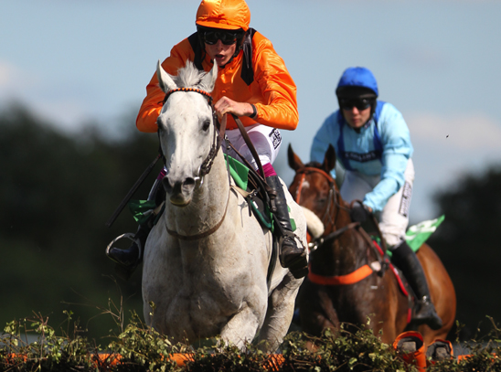
* 

**About the role**

To assist in maintaining the highest quality racing surface all year round. Maintenance of the outside areas to the highest possible standard of presentation. To assist in the maintenance of all track / kennel equipment. To assist with the smooth running of race meetings.

**Key responsibilities for the role will include**

This is a challenging yet rewarding role for a motivated individual. Although part of a team, working with one’s own initiative is vital in delivering the responsibilities within this role.

1. Under the direction of the Grounds Manager, learn and carry out maintenance programmes for the track. The work entails working outside in changing and often inclement weather conditions and can be physically demanding.
2. Assure the track surface is prepared accordingly prior to every trial and race meeting and maintained throughout meeting this will include:- Use of tractors, attachments, machinery and maintenance equipment as required.
3. Maintain all grass/non running surfaces with particular attention to raceday and event presentation.
4. General maintenance of external areas, to include car parks, tarmac areas and customer facing areas.
5. Ensure all external areas are free from weeds, rubbish and leaves.
6. You will be required to carry out checking and testing of racing equipment to ensure all equipment is functional and a professional appearance is maintained at all times.
7. Abide by all regulations and safe working practices in accordance as detailed in the Company’s Health and Safety Policy and Procedures.
8. Ensure compliance with all aspects of the GBGB rules of racing and report any and all issues to your line manager.
9. Ensure greyhound welfare is at the heart of everything you do and highlight any instances to your line manager where these standards are not met.
10. Due to the nature of this role, working unsocial hours will be a frequent occurrence, and may include late evenings, weekends and Bank Holidays.
11. Work Well in a team and have initiative to work by yourself.
12. Working closely with the kennels team, racing team and officials such as GBGB.

The above is not an exhaustive list of duties. The racecourse business is a dynamic and challenging environment and on occasion you will be required to assist in duties outside of those detailed in this job description and therefore a flexible approach is required.

**Skills and Qualities**

* Excellent time management skills
* Excellent attendance record
* Flexible approach to working
* Works well under pressure
* Organised
* Good Communication Skills
* Enjoy outdoor working
* Full clean driving licence
* Tractor driving experience an advantage

This role is part of the grounds team at the Stadium and you will be expected to participate in any grounds team meetings relating to all elements of the operational delivery of the racecourse and associated events.

**Other**

To comply with all Health and Safety procedures associated with the department at all times. This relates to:

* Standards and procedures of correct working practices
* The completion of risk assessments
* COSHH regulations
* Use of Personal Protective Equipment

To control wastage and operate according to the Companies environment policy with regard to:

* product control and waste minimisation
* proper care and maintenance of equipment to prolong its life
* using towels in appropriate quantity to minimise unnecessary laundering
* proper separation and disposal of cardboard, paper and glass in recycling bins
* minimising energy wastage by switching off unused lights, heating, PCs and equipment

To be an ambassador for ARC and for our site, taking personal responsibility for finding out about our product and services, and at all times striving to represent the Company in the most professional, courteous and efficient manner possible.

The above is not an exhaustive list of duties, and you will be expected to perform different tasks as necessitated by your changing role within the organisation and the overall business objectives of the organisation.

Signed by Employee………………………………………………… Date…………………………………………….

Signed by Line Manager…………………………………………… Date…………………………………………….